**ALL STAFF FORMS ARE DUE BY 11:59 PM, SUNDAY, APRIL 30, 2023\*\***

***Instructions: Please fill out all staff forms below.***

***For forms #2, #3, and #4, please fill out digitally & EMAIL US at*** [***sdcylcstaff@gmail.com***](mailto:sdcylcstaff@gmail.com) ***OR bring in the HARD COPY of your completed form and drop it off in our church mailbox (next to the main entrance doors).***

1. [Staff Medical Information](https://docs.google.com/forms/d/e/1FAIpQLSeigP9UqUDAE04aVpCH43J522GW2BBPbmmui9a2pMNhgbGmNw/viewform?usp=sf_link) (Google Form) (**ALL MUST FILL THIS FORM OUT BY THEIR ONBOARDING RETREAT DATE\*\***)
2. In Google Folder: [W-9 Form](https://drive.google.com/file/d/13XkhbqYlxOCdkSYB25rDHoo82SIqZAw3/view?usp=share_link) (**ALL STAFF**)
3. In Google Folder: [Staff Medical & Liability Release, Staff Agreement, & Media Release](https://drive.google.com/file/d/1MM5vR1lNHaWM3d5HTF-Yw77Ga5OomUul/view?usp=share_link) (**ALL MUST FILL THIS FORM OUT BY THEIR ONBOARDING RETREAT DATE\*\***)
4. In Google Folder: [Background Check Authorization Form](https://drive.google.com/file/d/14rq8mzDXX76dXcuGj7pbduYPE3ufra8d/view?usp=share_link) (**18 & UP ONLY**)

**How to input signatures from your macbook (using Preview):**

**Tools > Annotate > Signatures > Manage Signatures**

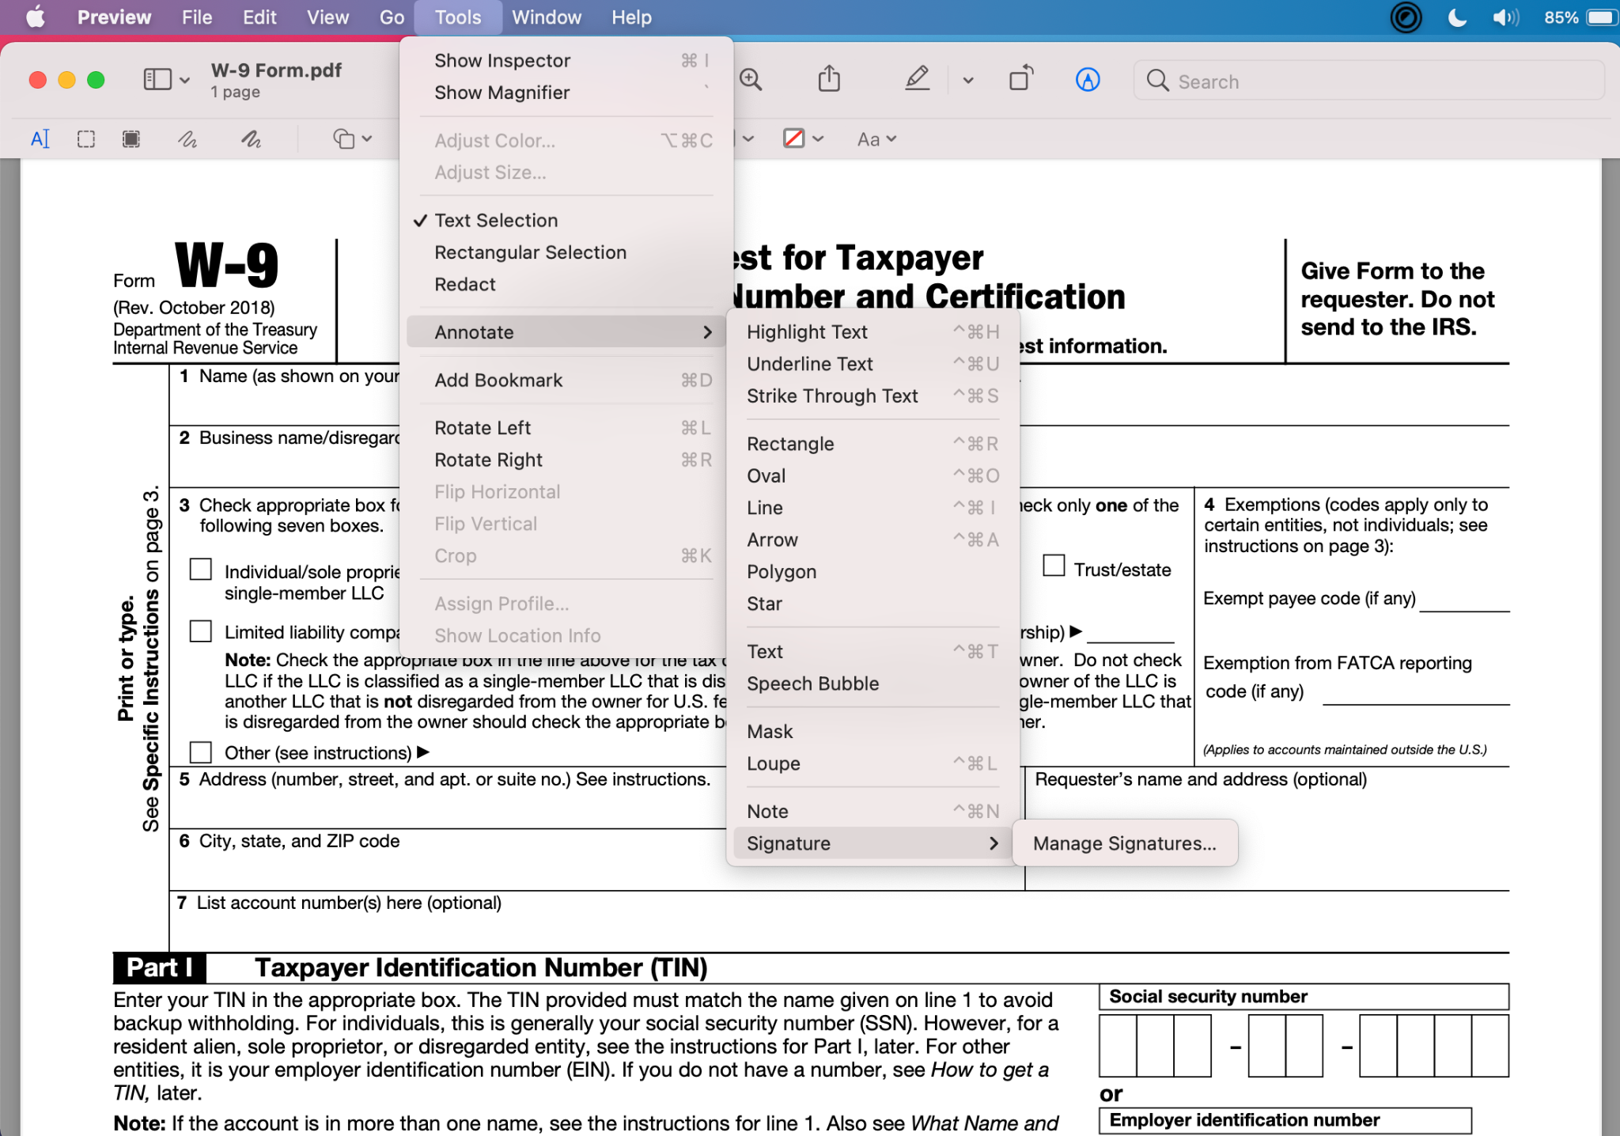

**OR**

**You can insert a signature this way**

